INTL4475: War & Gender
University of Georgia – Spring 2018
MWF 11:15-12:05, MLC 207

Dr. Maryann E. Gallagher
mgallag@uga.edu
Office: Candler 329
Office Hours: Wed. & Fri. 3:30-4:45, by appointment.

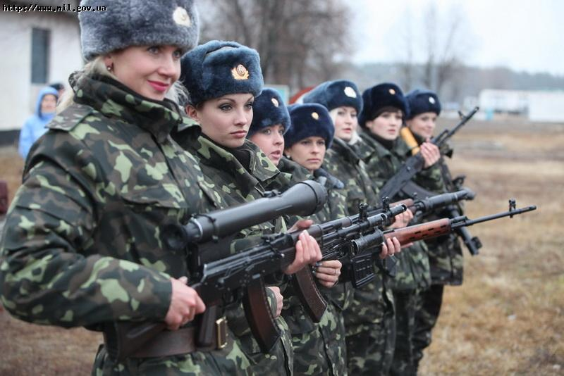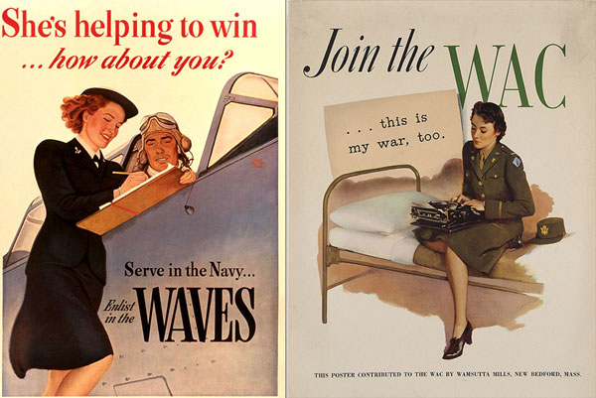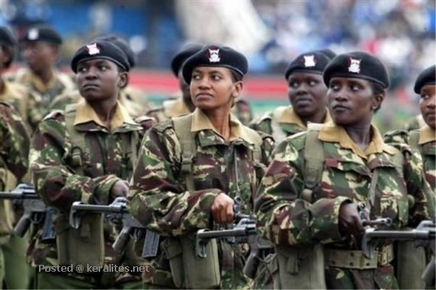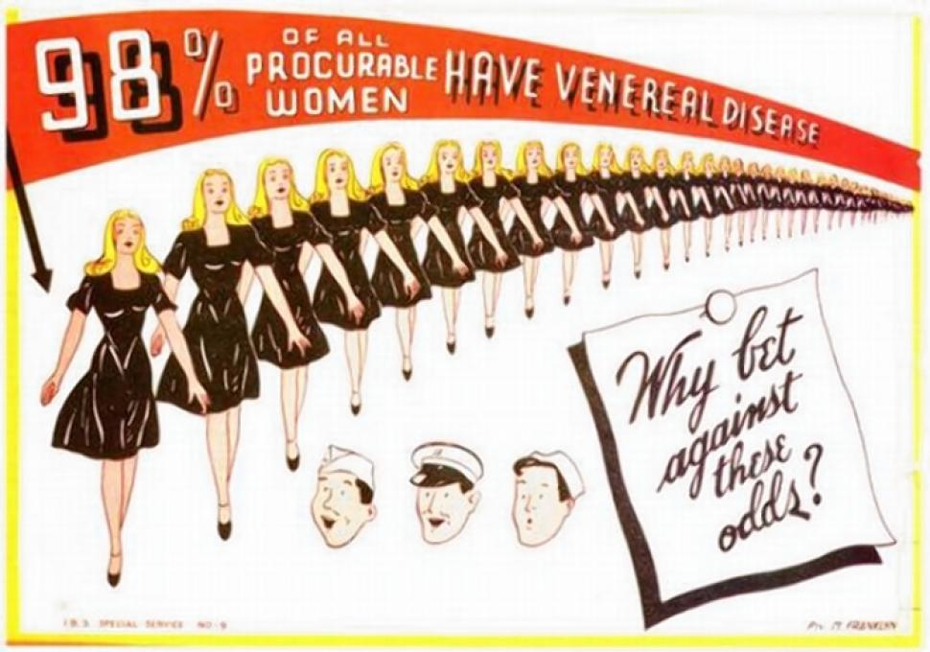

Course Overview:
The purpose of this course is to study the recursive relationship between conflict and gender, and to familiarize students with the ways scholars use gender as a lens when analyzing international conflict. Throughout the course we will consider how gender(ed) norms shape conflict and are likewise shaped by conflict. Students will learn how to apply a gender lens to their understanding of international affairs. They will be able to analyze how the construction, performance, and symbolic representations of masculinities and femininities shapes international relations.

The course will begin by examining why, despite variance in conflict types and gender, have gender roles in conflict been constant. That is, why have women historically been absent from combat? We will consider various theories to explain this outcome, cases that refute this relationship, and evaluate changes to women’s combat participation around the world. Students will consider how norms about gender and violence shape the behavior of warring parties during conflict, with regard to treatment of civilians as well as soldiers. Students will also consider the role of gender in conflict resolution, and how international norms and laws about equality have affected the establishment and maintenance of peace.

This course will be largely discussion based and requires students to come to class prepared to discuss the assigned readings. A significant portion of students’ grades will come from completing a group assignment (literature review and video) that examines some aspect of the relationship between war and gender.

Course Requirements:
- Readings: You are expected to complete the readings listed on the syllabus prior to coming to class. Failure to do so will be evident in your lack of participation during class discussions. Occasionally an article relevant to the topic we are covering will be published and I will assign it on short notice. In that case I will post the article to the “ANNOUCMENTS” section of the class ELC page. **PLEASE REGISTER FOR ANNOUCMENTS NOTIFICATIONS**

There are 2 required texts:

Joshua S. Goldstein. 2003. War and Gender: How Gender Shapes the War System and Vise Versa. Cambridge University Press.
ISBN: 978-0521001809

Jenny Nordberg. 2015. The Underground Girls of Kabul: In Search of a Hidden Resistance in Afghanistan. Broadway Books. ISBN: 978-0307952509

**All other readings can be found on ELC, unless otherwise noted.
**You are also required to keep up with current events – see below**

- Grading:
Final Exam - 25%
Journal – 20%
Quizzes – 22%
Participation – 10%
Final Project – 23% (10% presentation; 10% paper; 3% Reflection)

Letter grades correspond to the following 0-100 scale:
94-100 A 74-76 C
90-93 A- 70-73 C-
87-89 B+ 67-69 D+
84-86 B 64-66 D
80-83 B- 60-63 D-
77-79 C+ 00-59 F

- Written Assignments: All assignments are to be typed and handed in at the START of class on the due date (unless otherwise noted). Late assignments will be penalized 1% of your overall grade for each day late. All written assignments should meet the following formatting requirements: 12-point font, double spaced, 1” margins, and page number in bottom right hand corner.
- Quizzes: There will be 6-10 unannounced quizzes throughout the semester that will cover assigned readings and current events. You may use notes, but not the readings. Quizzes will be administered in the first 5 minutes of class – if you are late to class you will not be given additional time to complete the quiz. There are no makeup quizzes. Students who miss more than one quiz will have their first missed quiz dropped and receive a grade of zero for any additional missed quizzes.
- Journal: Each student will maintain an online journal where they can reflect on the issues discussed in the readings and class. You are free to draw on current events or pop-culture to motivate your post, however each post should make an explicit reference to at least one reading/lecture (include citation using CMS). Student must have 8 journal entries of at least 250 words with no more than 1 entry per week (the week starts on Sunday) – you may not submit entries for Weeks 14 & 15. Late posts will receive the same penalty as a late paper.
- Final Project: Each student will be part of a group that will be responsible for choosing an issue that falls under the topic of “War & Gender” (one that is not covered in depth in class) that they will conduct research on throughout the semester. Each group will submit a literature review on the issue and make a 10-minute video presentation to teach the class about the issue. Further details will be given in class.
- Participation: This course will require a great deal of discussion and active listening. Simply showing up to class does not constitute participation. Your participation grade will be evaluated based on your ability to draw upon insights from the readings, the depth of the thoughtfulness of your questions/comments, and your activeness in class, on discussion boards, and/or on twitter using #WomenWP
  - The nature of the topics we will discuss may often be contentious. Everyone is expected to be respectful of others’ perspectives and experiences.
  - Some topics may be emotionally challenging. Please know that you are always free to step outside the classroom if you need a break.
- Attendance: I will take attendance every class and I expect you to be present. You are allowed three absences without penalty. You can use these as you like (e.g. illness, sports travel, interviews, sleep, conferences). Each absence beyond these three will result in a 1-point deduction from your final overall average.

Other important information:
- Current Events: Students are required to stay up to date on world politics. I suggest that you browse the world news sections of the New York Times, The Wall Street Journal, The Guardian (UK), or the Washington Post on a regular basis. You can subscribe to various daily world news briefs and have them emailed to you (I highly recommend CFR’s daily email). CFR has a monthly bulletin on Women & Foreign Policy. It will be clear from your (lack of) participation in our discussions whether you are keeping up with world politics and this will be factored into your participation grade.
- Technology:
  - Laptops are not welcome in class, unless I instruct you to bring one. Should you need to use a laptop please provide proper documentation from UGA’s DRC.
  - All cell phones should be shut off or set to silent – NOT VIBRATE – before arriving to class. The use or interruption of these devices during regular class time will result in a reduction of your participation grade.
- Communication and Email: I will keep you updated about the course and any changes to the syllabus through the “ANNOUCEMENTS” board on the class ELC page – PLEASE REGISTER FOR NOTIFICATIONS!
  - When emailing me please use your UGA email account and include your course number in the subject line. In most cases I will respond to emails within 24 hours. Importantly, before you email me please check the syllabus and the news page of the ELC site to be sure that your question has not been previously addressed.
  - A note on etiquette: please use appropriate salutations, including my name in the opening and your name in the closing. (Hint: you can’t go wrong with “Hi Professor Gallagher”). For further guidance see http://www.wikihow.com/Email-a-Professor.
- Office Hours – I will be available to meet with students during the office hours listed above, however the only way to guarantee that we will have time to meet is for you to sign up for an appointment using the following link (also posted to the ELC page): https://docs.google.com/document/d/11V8ETwJbmKJ8ah9eIUtH0YRyf0B7wFSLWYWUS3j4GTc/edit).
- Academic Dishonesty – As a University of Georgia student, you have agreed to abide by the University’s academic honesty policy, “A Culture of Honesty,” and the Student Honor Code. All academic work must meet the standards described in “A Culture of Honesty” found at: http://www.uga.edu/honesty. Lack of knowledge of the academic honesty policy is not a reasonable explanation for a violation. Any student caught cheating or plagiarizing will be referred to Judicial Affairs, as required by university policy. The most common issue of academic dishonesty I have come across is plagiarism. To be clear, plagiarism is copying from any source material (direct or paraphrasing of ideas), published or unpublished (this includes wikipedia!), without giving proper credit. I will post a link to the Chicago Manual of Style citation format on ELC.
- Students with Disabilities: UGA is committed to providing equal access to academic programs and university-administered activities and reasonable modifications to students with disabilities. Students in need of special accommodations need to request such services from the Disability Resource Center located at 114 Clark Howell Hall (for more information visit www.drc.uga.edu) and should make an appointment to see me with their appropriate paperwork from DRC within the first two weeks of classes.
- UGA’s code of conduct protects student privacy and intellectual property and thus prohibits recording and digital release of classroom lectures and conversations unless a student has an accommodation from the DRC. If this is your situation, please let me know and we will devise an accommodation that protects your right to privacy, that of your classmates, and everyone’s intellectual property.
- This syllabus is subject to changes throughout the semester.

CLASS SCHEDULE AND READINGS

WEEK 1: Introduction to the Field
Fri., January 5 (class 1) – Introduction

Mon., Jan. 8 (class 2) – Understanding “Gender” and “War”
- Carol Cohn. 2013. “Women and Wars: Toward a Conceptual Framework” in Women and Wars. Pp.1-30
- Trishna Rana and Marie Berry. 12/17/15. “A Woman Did That? Thoughts on Women Perpatrators of Violence.” Available at: http://politicalviolenceataglance.org/2015/12/17/a-woman-did-that-thoughts-on-women-perpetrators-of-violence/

Wed., Jan. 10 (class 3) – Feminist IR Theories (Last Day to Add/Drop)
- Goldstein pp. 34-52
- Ann Tickner. 1997. “You just Don’t Understand: Troubled Engagements Between Feminists and IR Theorists” International Studies Quarterly. Pp. 611-632

Fri., Jan. 12 (class 4) – Traditional Explanations for War
- Frieden, Lake, and Schultz. World Politics: Interests, Interactions, Institutions. Ch. 3: Why are there wars?

WEEK 2: Women’s Participation in War
Mon., Jan. 15 – No Class: MLK Day of Service

Wed., Jan. 17 (class 5) – The Participation (And absence) of women in War
- Goldstein Ch. 1 pp. 1-11
- Goldstein Ch. 2
  - **GET STARTED EARLY!
- Women and Men’s support for war: http://www.e-ir.info/2012/01/19/men-and-womens-support-for-war-accounting-for-the-gender-gap-in-public-opinion/
- Women’s Perception of Drones: http://www.pewresearch.org/fact-tank/2013/07/25/big-gender-gap-in-global-public-opinion-about-use-of-drones/

Fri., Jan. 19 (class 6) – Gendered Security Discourse
- Carol Cohn. 1987. “Sex and Death in the Rational World of Defense Intellectuals.” Signs.

WEEK 3: Nature vs. Nurture?
Mon., Jan. 22 (class 7) – Biological basis for the absence of female combatants
- Goldstein Ch. 3

Wed., Jan. 24 (class 8) – Examining Social Hierarchy and Sex Segregation
- Goldstein Ch. 4 (you can skip p. 184-194 on primates)

Fri., Jan. 26 (class 9) – Discussing the Final Project
- No reading

WEEK 4: Women’s Inclusion in Combat
Mon., Jan. 29 (class 10) – War: The Making of Masculinity
- Goldstein Ch. 5

Wed., Jan. 31 (class 11) – The U.S.’s Decision to Lift the Ban on Women in Combat
- “Putting Women in Combat is a Disastrous Decision.” Available at: http://www.usnews.com/debate-club/should-women-be-allowed-to-fight-in-combat/putting-women-in-combat-is-a-disastrous-decision
- Dardent and Szekely. 2015. “Warfare Isn’t Just a Man’s Game Anymore.” WaPo. Available at: http://www.washingtonpost.com/blogs/monkey-cage/wp/2015/02/09/warfare-isnt-just-a-mans-game-anymore/
- Ellen Haring and Megan MacKenzie. “Exclusive Access to Marine Corps Study Show it Misses the Mark.” http://meganhmackenzie.com/2015/10/14/exclusive-access-to-marine-corps-study-shows-it-misses-the-mark/?preview_id=456
- Megan MacKenzie. “True Grit: The Myths and Realities of Women in Combat.” Foreign Affairs.
- “For 3 Women, Combat Option Came a Bit Late.” 1/26/13. NYT. Available at: http://www.nytimes.com/2013/01/27/us/for-3-women-combat-option-came-a-bit-late.html?ref=jamesdao&_r=1

Fri., Feb. 2 (class 12) – Female Engagement Teams and CSTs
- Synne Dyvik. 2013. Women as ‘Practitioners’ and ‘Targets’: Gender and Counterinsurgency in Afghanistan” International Feminist Journal of Politics

WEEK 5: Women’s Participation in Political Violence
Mon., Feb. 5 (class 13) – Organizations and Incentives
- Miranda Alison. 2004. “Women as Agents of Political Violence: Gendering Security.” Security Dialogue. 447-463.

Wed., Feb. 7 (class 14) – Women and Armed Rebellion
- Alexis Henshaw. 2015. “Where Women Rebel: Patterns of Participation in Armed Rebel Groups 1990-2008.” International Feminist Journal of Politics.

Fri., Feb. 9 (class 15) – “Idealized Militarized Femininity”
- Laura Sjoberg. 2007. “Triple Transgressions at Abu Ghraib.” In Mothers, Monsters, and Whores.
- Laura Sjoberg. 2007. “Agency, Militarized Femininity, and Enemy Others: Observations from the War in Iraq.” International Feminist Journal of Politics. **Read only p. 85-87 (the Jessica Lynch story) and 92-99.

WEEK 6: Terrorism
Mon., Feb. 12 (class 16) – Gender and Terrorism
- Sjoberg, Cooke and Neal. 2011. “Introduction: Women, Gender, and Terrorism” in Women, Gender, and Terrorism. Pp. 1-15 only (pay particular attention to sections on how to define terrorism).
- Gentry and Sjoberg. 2011. “The Gendering of Women’s Terrorism” in Women, Gender and Terrorism. Pp. 57-76.
- Brigitte L. Nacos. 2005. The Portrayal of Female Terrorists in the Media: Similar Framing Patterns in the News Coverage of Women in Politics and in Terrorism. Studies in Conflict and Terrorism. 435-451.

Wed., Feb. 14 (class 17) – Female Suicide Terrorism
- Lindsey O’Rourke. 2009. What’s Special About Female Suicide Terrorism? Security Studies. 681-718.
  - **only pages 681-700

Fri., Feb. 16 (class 18) – The Terrorist in Their Own Words: Agency or Exploitation?
- Caron E. Gentry. 2011. “The Committed Revolutionary: Reflections on a Conversation with Leila Khaled” in Women, Gender, and Terrorism.
- Lihi BenShitrit. 2015. Excerpt on Reem Riyashi in Righteous Transgressions. Pp. 168-179.

WEEK 7: Gender and State Security
Mon., Feb. 19 (class 19) – Inequality and Conflict
- Mary Caprioli. 2005. Primed for Violence: The Role of Gender Inequality in Predicting Internal Conflict. International Studies Quarterly.
- Valerie Hudson. 2012. “What Sex Means for World Peace.” Foreign Policy.

Wed., Feb. 21 (class 20) – Masculinity, Bride Price, and Terrorism
- Valerie Hudson and Hilary Matfess. 2017. In Plain Sight: The Neglected Linkage Between Bride Price and Violent Conflict. International Security. Pp. 7-40.

Fri., Feb. 23 (class 21) – Transgender in the Military
- NY Times Op-Doc: Transgender, at War and in Love http://www.nytimes.com/video/opinion/100000003720527/transgender-at-war-and-in-love.html
- Rand Study. TBD.

Week 8: Gender and International Actors
Mon., Feb. 26 (class 22) – Gender Norms During War
- R. Charli Carpenter. 2003. ‘Women and Children First’: Gender, Norms, and Humanitarian Evacuation in the Balkans 1991-95. International Organization.

Wed., Feb 28 (class 23) – UNSCR 1325 & The Gender Peace and Security Agenda
- Paul Kirby and Laura Shepherd. 2016. The Futures Past of the Women, Peace, and Security Agenda. International Affairs. 373-392.
- UNSCR 1325 Available at: http://www.un.org/en/ga/search/view_doc.asp?symbol=S/RES/1325%282000%29

Fri., March 2 (class 24) – Implementing 1325: Challenges
- Sabrina Karim and Kyle Beardsley. 2013. Female Peacekeepers and Gender Balancing: Token Gestures or Informed Policymaking? International Interactions.

WEEK 9: Women & Conflict Resolution
Mon., March 5 (class 25) – Getting Women to the Table
- Sandra McEvoy. 2009. Loyalist Women Paramilitaries in Northern Ireland: Beginning a Feminist Conversation about Conflict Resolution. Security Studies.
- Carol Cohn and Ruth Jacobson. 2013. “Women and Political Activism in the Face of War and Militarization” in Women and Wars. 102-123.
- “Where Women Are Leading The Peace” http://foreignpolicy.com/2015/09/30/where-women-are-leading-the-peace-security/

Wed., March 7 (class 26) - “Pray the Devil Back to Hell”
- Sanam Naraghi Anderlini. 2007. “Getting to the Peace Table” (excerpt from Women Building Peace)

Fri., March 9 (class 27) – Finish & Discuss “Pray the Devil Back to Hell”
- No Reading (but be prepared to discuss Anderlini reading from Wed)

March 12-16 – NO CLASSES: SPRING BREAK

WEEK 10: Gendering the Post-Conflict State
Mon., March 19 (class 28) – Disarmament, Demobilization, and Reintegration
- Megan MacKenzie. 2009. Securitization and Desecuritization: Female Soldiers and the Reconstruction of Women in Post-Conflict Sierra Leone. Security Studies. Pp. 241-261.
**Withdrawal Deadline – March 19**

Wed., March 21 (class 29) – Post-War Gender Reconstruction
- Nadje Al-Ali. 2005. Reconstructing Gender: Iraq between dictatorship, war, and occupation. Third World Quarterly. 739-758.

Fri., March 23 (class 30) – Refugees
- Alison Gerard and Sharon Pickering. 2013. Gender, Securitization and Transit: Refugee Women and the Journey to the EU. Journal of Refugee Studies, Vol. 27, No.3. 338-359.

WEEK 11: Sexual Violence in War
Mon., March 26(class 31) – Rape as a “weapon” of War?
- Carter. 2010. Should International Relations Consider Rape a Weapon of War? Politics & Gender. 343-371
- Letter from the Missing Peace Young Scholar Network: http://www.usip.org/sites/default/files/files/UK-ESVC-Letter-20140609.pdf
- Elisabeth Jean Wood. 2015. Conflict-Related Sexual Violence and the Policy Implications of Recent Research. International Review of the Red Cross. Pp. 457-478.

Wed., March 28 (class 32) – Complicating the Perpetrator/Victim Binary
- Cohen, Dara Kay. 2013. Female Combatants and the Perpetration of Violence: Wartime Rape in the Sierra Leone Civil War. World Politics. 383-415.

Fri., March 30 (class 33) – Sexual Violence Against Men During War
- “The Rape of Men: The Darkest Secret of War.” 7/16/11. The Guardian. http://www.theguardian.com/society/2011/jul/17/the-rape-of-men

WEEK 12: Sexual Violence in the Military

Mon., April 2 (class 34) – Sexual Assault in the Military
- Elisabeth Jean Wood and Nathaniel Toppelberg. 2017. The Persistence of Sexual Assault Within the US Military. Journal of Peace Research. Pp. 620-633.
- “In the War Against Sexual Assault, the Army Keeps Shooting Itself in the Foot.” 12/19/15. WaPo. https://www.washingtonpost.com/news/checkpoint/wp/2015/12/19/in-the-war-against-sexual-assault-the-army-keeps-shooting-itself-in-the-foot/
- Nathaniel Penn. 2014. “Son, Men Don’t Get Raped.” GQ Longform. Available at: http://www.gq.com/long-form/male-military-rape

Wed., April 4 (class 35) – NO CLASS: International Studies Association Annual Meeting
- Meet with Groups for final project

Fri., April 6 (class 36) – Introduction to The Underground Girls of Kabul (TUGK)
- Nordberg p. 1-48

WEEK 13: TUGK
Mon., April 9 (class 37) – TUGK
- Nordberg p. 49-160

Wed., April 11 (class 38) – TUGK
- Nordberg – pgs. 163-192
- “US Soldiers Told to Ignore Sexual Abuse of Boys by Afghan Allies.” 9/20/15. NYT http://www.nytimes.com/2015/09/21/world/asia/us-soldiers-told-to-ignore-afghan-allies-abuse-of-boys.html?_r=0

Fri., April 13 (class 39) –TUGK
- Nordberg – pgs. 193-231

WEEKS 14 & 15: Conclusion & Presentations
Mon., April 16 (class 40) – TUGK Conclusion
- Nordberg – pgs. 233-311

Wed., April 18 (class 41) – Presentations

Fri., April 20 (class 42) – Presentations

Mon., April 23 (class 43) – Presentations

Wed., April 25 (class 44) – Presentations

*****Final Exam due Friday, April 27 at noon

